Packet Tracer – Investigating NAT Operation

1. Topology

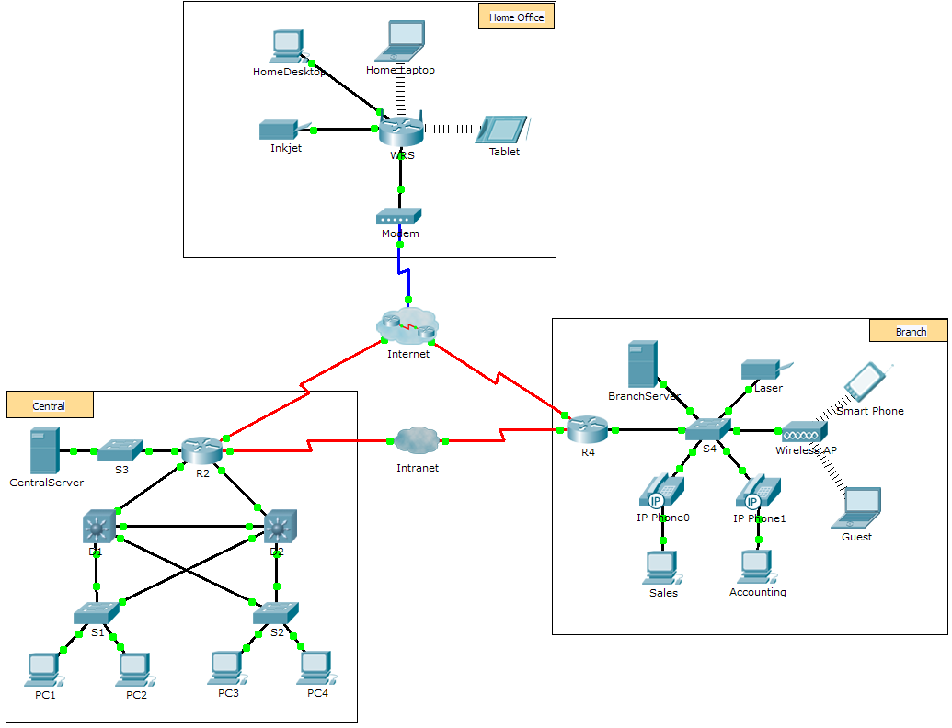

1. Objectives

Part 1: Investigate NAT Operation Across the Intranet

Part 2: Investigate NAT Operation Across the Internet

Part 3: Conduct Further Investigations

1. Scenario

As a frame travels across a network, the MAC addresses may change. IP addresses can also change when a packet is forwarded by a device configured with NAT. In this activity, we will investigate what happens to IP addresses during the NAT process.

1. Investigate NAT Operation Across the Intranet
   1. Wait for the network to converge.

It might take a few minutes for everything in the network to converge. You can speed the process up by clicking on Fast Forward Time.

* 1. Generate an HTTP request from any PC in the Central domain.
     1. Open the Web Browser of any PC in the **Central** domain and type the following without pressing enter or clicking **Go**: **http://branchserver.pka**.
     2. Switch to **Simulation** mode and edit the filters to show only HTTP requests.
     3. Click **Go** in the browser, a PDU envelope will appear.
     4. Click **Capture / Forward** until the PDU is over **D1** or **D2**. Record the source and destination IP addresses. To what devices do those addresses belong?

____________________________________________________________________________________

____________________________________________________________________________________

* + 1. Click **Capture / Forward** until the PDU is over **R2**. Record the source and destination IP addresses in the outbound packet. To what devices do those addresses belong?

____________________________________________________________________________________

____________________________________________________________________________________

* + 1. Login to R2 using ‘**class**’ to enter privileged EXEC and show the running configuration. The address came from the following address pool:

ip nat pool R2Pool 64.100.100.3 64.100.100.31 netmask 255.255.255.224

* + 1. Click **Capture / Forward** until the PDU is over **R4**. Record the source and destination IP addresses in the outbound packet. To what devices do those addresses belong?

____________________________________________________________________________________

____________________________________________________________________________________

* + 1. Click **Capture / Forward** until the PDU is over **Branserver.pka**. Record the source and destination TCP port addresses in the outbound segment.
    2. On both **R2** and **R4**, run the following command and match the IP addresses and ports recorded above to the correct line of output:

R2# **show ip nat translations**

R4# **show ip nat translations**

* + 1. What do the inside local IP addresses have in common? ______________________________________
    2. Did any private addresses cross the Intranet? ______________
    3. Return to **Realtime** mode.

1. Investigate NAT Operation Across the Internet
   1. Generate an HTTP request from any computer in the home office.
      1. Open the Web Browser of any computer in the home office and type the following without pressing enter or clicking **Go**: **http://centralserver.pka**.
      2. Switch to **Simulation** mode. The filters should already be set to show only HTTP requests.
      3. Click **Go** in the browser, a PDU envelope will appear.
      4. Click **Capture / Forward** until the PDU is over **WRS**. Record the inbound source and destination IP addresses and the outbound source and destination addresses. To what devices do those addresses belong?

____________________________________________________________________________________

____________________________________________________________________________________

* + 1. Click **Capture / Forward** until the PDU is over **R2**. Record the source and destination IP addresses in the outbound packet. To what devices do those addresses belong?

____________________________________________________________________________________

* + 1. On **R2**, run the following command and match the IP addresses and ports recorded above to the correct line of output:

R2# **show ip nat translations**

* + 1. Return to **Realtime** mode. Did all of the web pages appear in the browsers? ______________

1. Conduct Further Investigations
   * 1. Experiment with more packets, both HTTP and HTTPS. There are many questions to consider such as:

- Do the NAT translation tables grow?

- Does WRS have a pool of addresses?

- Is this how the computers in the classroom connect to the Internet?

- Why does NAT use four columns of addresses and ports?

1. Suggested Scoring Rubric

|  |  |  |  |
| --- | --- | --- | --- |
| Activity Section | Question Location | Possible Points | Earned Points |
| Part 1: Request a Web Page Across the Intranet | Step 2d | 12 |  |
| Step 2e | 12 |  |
| Step 2g | 13 |  |
| Step 2j | 12 |  |
| Step 2k | 12 |  |
| **Part 1 Total** | | 61 |  |
| Part 2: Request a Web Page Across the Internet | Step 1d | 13 |  |
| Step 1e | 13 |  |
| Step 1g | 13 |  |
| **Part 2 Total** | | **39** |  |
| **Total Score** | | **100** |  |